**TYPE’S OF IP’S**

**Public IP**

Which can be accessed from internet

Public IP is optional

Public IP is dynamic

If you STOP and START the EC2 instance public IP will be change

AWS assign public IP to the EC2 instances

**Private IP**

Which cannot access from internet

Private IPs are mandatory

It will use within VPC’s

**Elastic IP**

Same as public IP and ELP is STATIC

If you STOP and START the EC2 instance, EIP will not change and ***5 EIP’s are FREE***

**EIP will be provided to the AWS**

If you have not associated EIP to any instance, it will be charged if those EIP’s are below 5 also, don’t waste it and should not keep it idle

An Elastic IP Address STATIC IP4 Address associated with an AWS account, can be attached to an EC2 Instance.

Idle EIP’s are charged

**When to use Elastic IP Address:**

AWS Cloud provides ability to stop/start/terminate the EC2 instances at any time, the public IP associated with instance also get released when you terminate the instance. After the instance stop/start there is no guarantee that you are going to get the same public IP address. This makes outage situation -as original Public IP address associated with your DNS (website address example) is gone. Elastic IP address makes life easy as it is reserved public IP address dedicated for your account.

**Features of Elastic IP Address:**

* An Elastic IP address can only be associated with one EC2 instance at a time.
* An Elastic IP address belongs to AWS account, not dedicated to instance, so it can be attached to any instance
* An Elastic IP address is static, i.e., they never get change/release unless you release those.
* An Elastic IP address is region specific only, i.e Elastic IP of Syndney Region can’t be used in Mumbai region.
* An Elastic IP address can be associated/disassociated to an instance irrespective of its state i.e running or powered off.

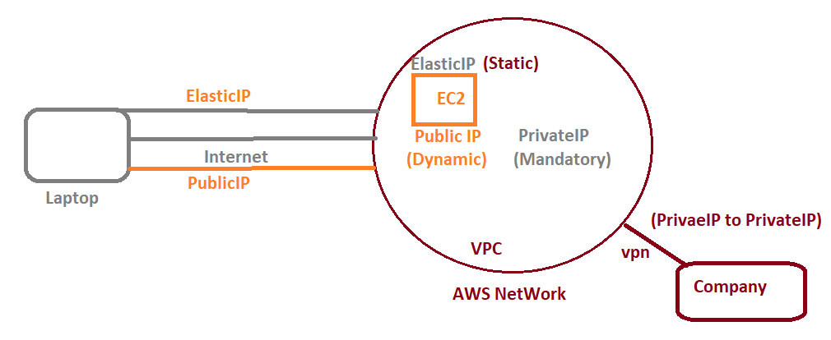

**Note**

From Laptop we can access EC2 instance via public IP or Elastic IP

From the company we will be connected to AWS (via VPN)

VPN is always private to private (within the VPN)

**It is not possible public + Elastic IP**

**Public + Private + EIP (not possible)**

Below combination will be accepted:

**Public + Private IP**

**Private + Elastic IP**

**Private**

**Instance Meta-Data**

Data about instance is called *“Instance Meta-Data”*

From console, we can get the instance meta-data from ***Description section***

If we want to get information from programmatically will use below URL(*Need to run in KURL*)

[**http://169.254.169.254/latest/meta-data/**](http://169.254.169.254/latest/meta-data/) **🡪 Programmatically**

**User Data (Bootstrap Script)**

The script which you provide will run at boot time of EC2 instance

Linux 🡪 Shell Script

Windows 🡪 PowerShell

**(new)Global Accelerator**

if their Mumbai regain, one guy sitting in USA will try to access AWS net work will get high latency

in b/w many hubs that’s the reason will get high latency, by using cloud front (CDN) customer can connect AWS network will get low latency.

There is another customer with fire wall setting need to access AWS network, he is asking about static IP’s for connecting AWS n/w but we should not provide public or static ips to customer for that we have another feature in AWS called Global Accelerator (newly launched)

GA provides 2 static ip’s ,we can assign this to customer and customer will connect to GA and once he connect GA customer will get low latency

Customer 🡪 GA ----- AWS internal n/w-----🡪 ELB

Global Accelerator will support static ip and will improve the performance

And customer can connect from CDN 🡪 GA 🡪 ELB (will get cache)

Only difference is CDN will cache and ***GA will not cache***

GA will be charged

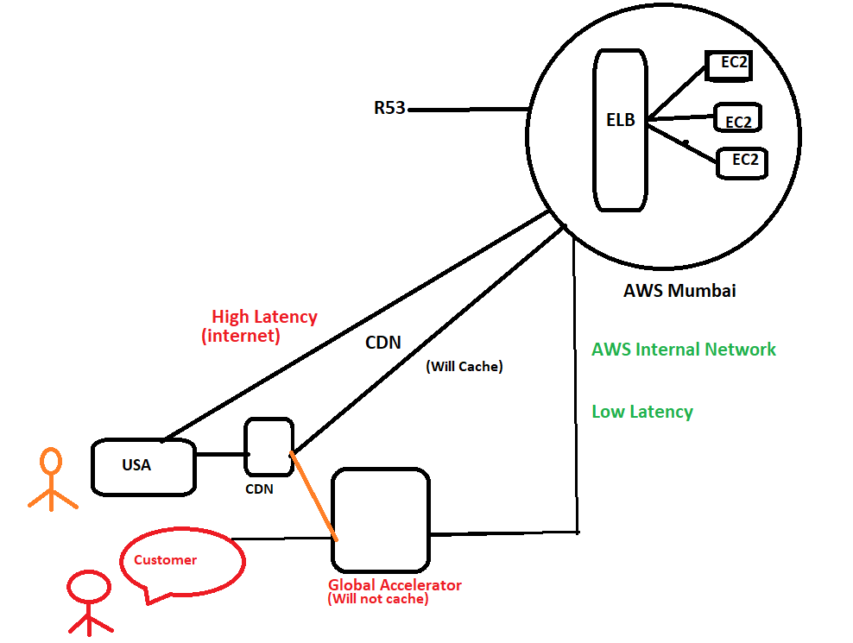

EC2 Instance

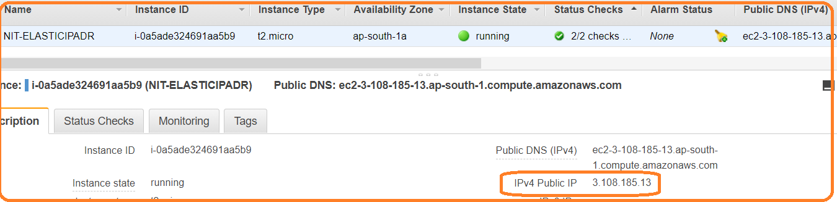

IPv4 Public IP : 3.108.185.13

If STOP/START the instance then, above IP address will be change



If STOP status public IP address will be released

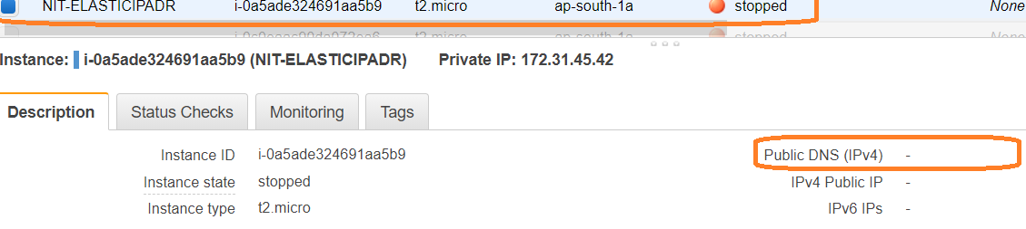

**Note:** If RESTART status public IP address won’t change.

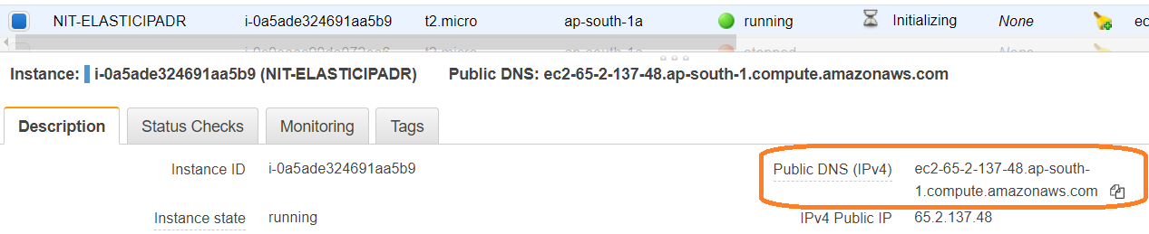

IPv4 Public IP 65.2.137.48

Creating Elastic IP address to instance:

1. In EC2 Dashboard, Click on Elastic IP which is present in the left panel under the “ Network & Security ” section.

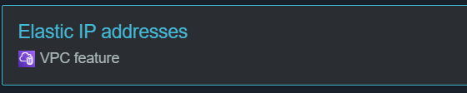

Click on Allocate Elastic IP address

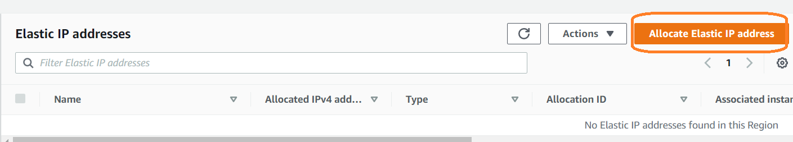

Click on **“Allocate”**

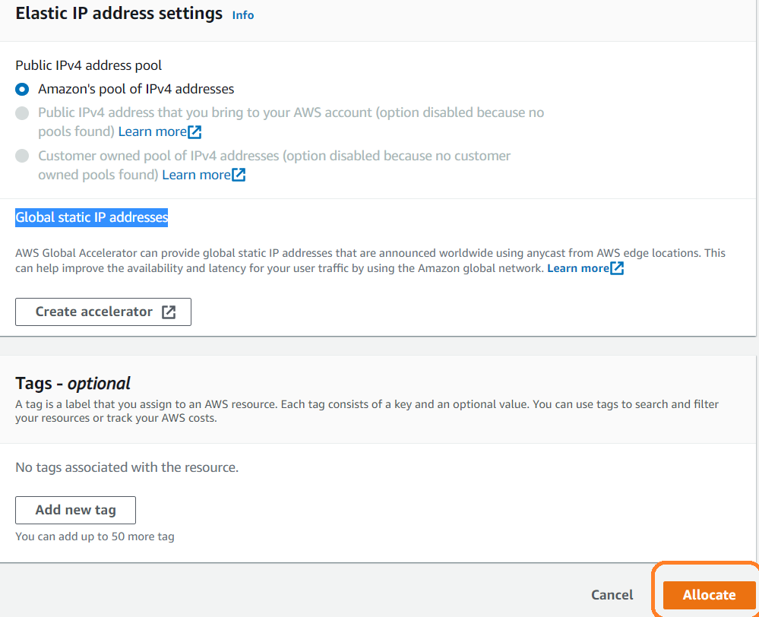

Click on **Allocate**,

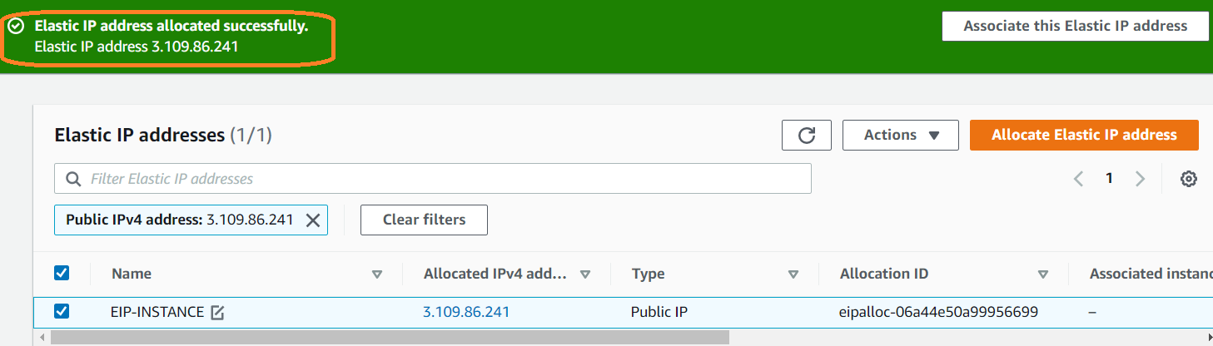

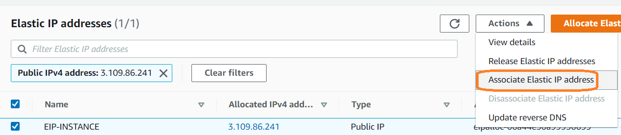

Once click Associate Elastic IP address, will get below page and under instance table list of instances will show in drop down.

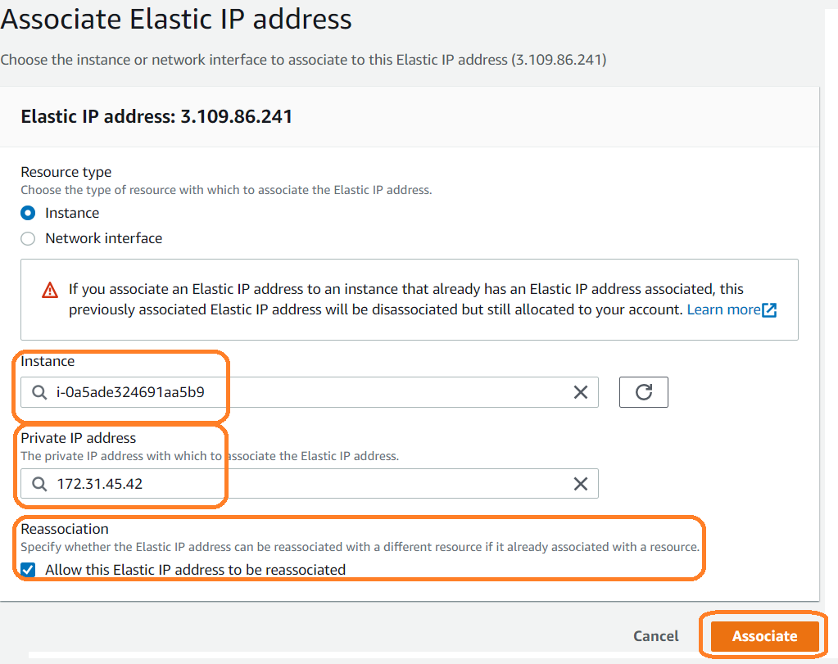

Click on **“Associate”**

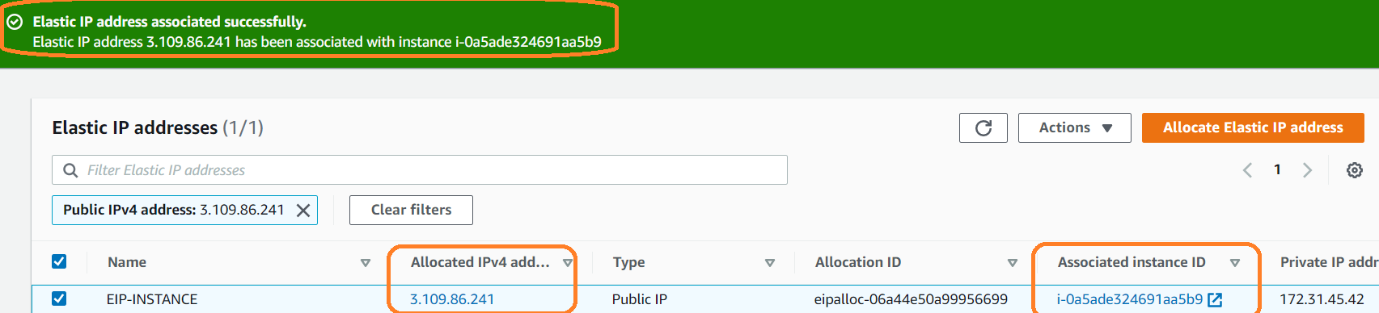

Elastic IP address is associated with below instance

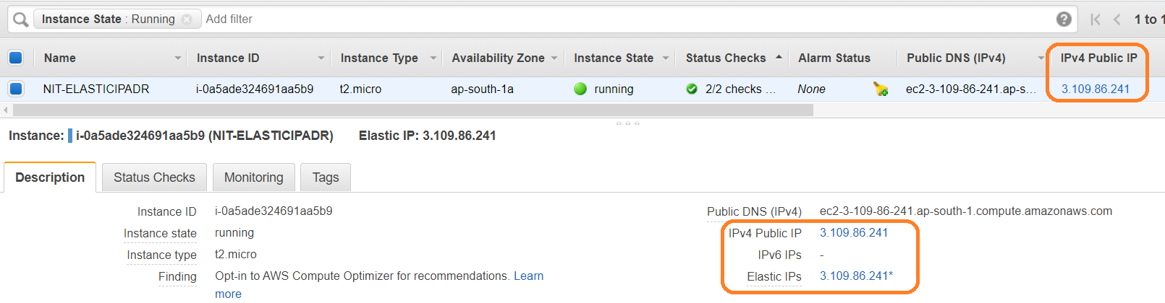

We can Disassociate Elastic IP address

